Team Darraptor

Sridhar Rangan

Hussain Dar

Mobile App Final Project

December 7, 2017

Final Report – Team Darraptor – UML Study Buddy App

**Project Goals:**

The purpose of this project was to design an application which helps to connect UMass Lowell students who are in need of help for classes. Our app, UML Study Buddy is designed to help students get to know other students in specific classes. The app will help so that students can meet up to work together on homework, study for quizzes and exams and do group projects together. UML Study Buddy will be available for all CS students and will help introverted students and those who will need help in their classes find additional help with their own peers.

**Project Features:**

This app features an account/login system using Firebase. The registration system for the app works by registering an email with an associated password. The login system will take the registered email and password and display the home screen with a welcome. UML Study Buddy features a list of classes for users to choose from so they can ask for help. Once a class is picked from our list, students can add details such as what assignment they need help in. The student’s post will be reflected on the main page of the app. Another feature is our button which links to UMass Lowell’s Centers for Learning and their schedule for tutors each day.

**Project Design:**

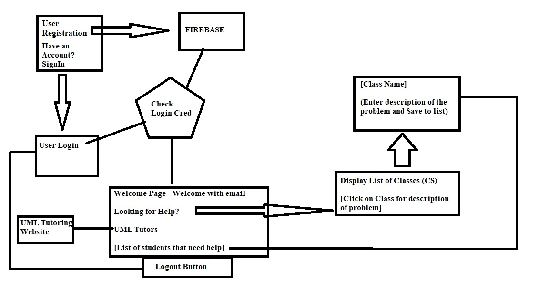

**File Structure:**

**AddDetailsActivity.java**

-Adds the classes to the database

-Done by: Sridhar Rangan

**Constants.java**

-Holds a blank list in the Firebase database

-Done by Sridhar Rangan

**FirebasDatabaseHandle.java**

-Stores the data as JSON

-Done by Sridhar Rangan

**HelpActivity.java**

-This is where the specific class name and course number are created with help from the word.java file

-Done by Hussain Dar

**HelperAdapter.java**

-Contains the layout for each of the already specifically made classes

-Done by Hussain Dar

**HttpRequestHandler.java**

-Allows the user to access the tutoring site

-Done by Hussain Dar and Sridhar Rangan

**LoginActivity.java**

-Allows the user login with their student email

-Done by: Sridhar Rangan

**MainActivity.java**

-Links all the files together

-Done by: Hussain Dar and Sridhar Rangan

**ProfileActivity.java**

**Word.java**

-Creates the shell of the class for the courseName, courseInfo, courseNumber and the user’s email

-Done by Hussain Dar

**WordAdapter.java**

-Provides the layout for each of the shell classes.

-Done by Hussain Dar

**colors.xml**

-Holds the colors of the layout of the page

-Done by Hussain Dar

**dimens.xml**

-Holds the dimensions of the page

-Done by Sridhar Rangan

**Strings.xml**

-Holds basic phrases that ask what the user wants such as logging in or asking for help etc.

-Done by Sridhar Rangan

**Styles.xml**

**-**Holds the basic application theme with the styles for the vocabulary words

-Done by Hussain Dar